created 04/24/2018, updated 04/14/2020

Incubator CLient Handbook
For tenants leasing space in the incubation program
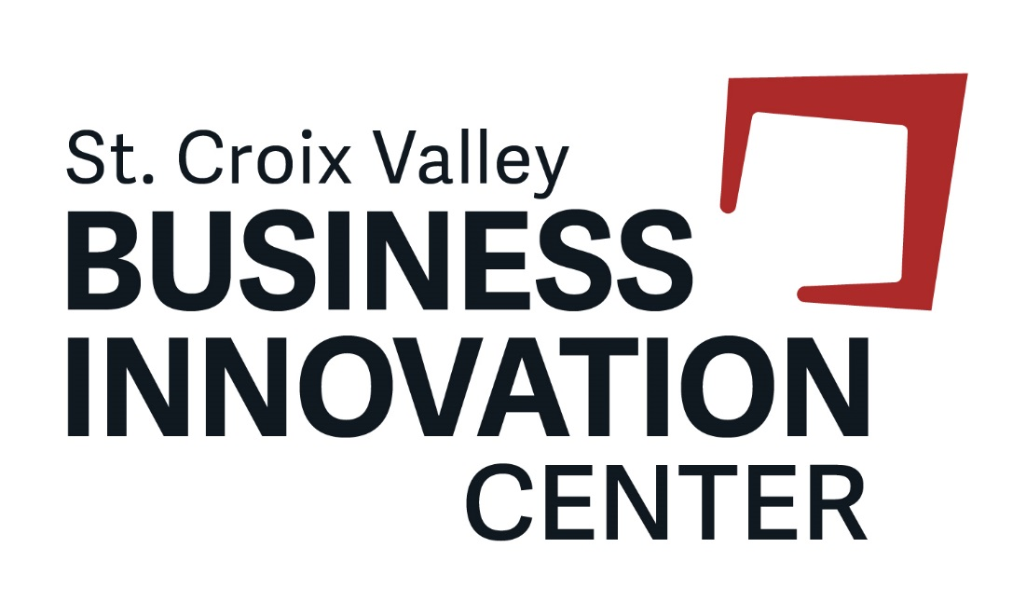
Table of Contents
Overview 2
Contacts 2
Incubator Program Requirements 3
Program Graduation Policy 3
Management Assistance 4
Administrative Assistance 4
Access to Premises 5
Shared-use Equipment 6
Internet Access and Use 7
Care of Premises 7
Agreement 8

Overview

Welcome to the St. Croix Valley Business Innovation Center’s Incubator Program. You have joined a business support program that accelerates the successful development of start-up and established companies by providing business owners and employees with an array of targeted resources and services. Entrepreneurs and small businesses can access resources to connect, support and grow their business.

As a participant in the Incubator Program, you will have access to management guidance, technical assistance and consulting customized to the needs of your growing business. A basic outline of the services and support available to you is summarized in this handbook.

Location: The St. Croix Valley Business Innovation Center is located in the Sterling Ponds Corporate Park in River Falls, WI. The Innovation Center includes approximately 30,000 square feet of leasable space with adjacent parking areas. The building is fully equipped with a sprinkler and fire alarm system tied directly to the fire department.

Incubator Program Companies may use the following information for mail, stationery, telephone listing, etc.:

Your Company Name
1091 Sutherland Ave
Suite [enter your room number]
River Falls, WI 54022

Contacts

Title Staff Name Email Phone
Interim Director Sheri Marnell Sheri.Marnell@uwrf.edu 715-425-4288

For medical emergencies, call 9-1-1. For non-emergency issues or issues during normal working hours please call the Receptionist at 715-425-3066. For serious issues outside of business hours, call the Center Director at 651-323-8002.

1091 Sutherland Avenue
River Falls, WI 54022
www.StCroixInnovation.org
715-425-3066

Incubator Program Requirements

Businesses leasing space in the facility must agree to participate in the Incubator Program. The typical program and lease commitment is 2-3 years with the option of yearly extensions after the initial lease period upon approval by the Incubator Management Committee. Incubator Program clients are required to:

- Meet, at a minimum, quarterly with the Director of the St. Croix Valley Business Innovation Center to create an action plan, set goals and review performance.
- Set up an initial consultation with the UW-River Falls Small Business Development Center consultant and follow suggestions regarding additional meetings throughout your occupancy.
- Meet, as requested, with the Board of Advisors and present (pitch) your business idea and incorporate feedback/act on advice (typically twice per year).
- Attend, at minimum, one networking event, training session, class or workshop offered by the Innovation Center per year.
- Respond to electronic survey requests on a timely basis and answer all questions truthfully and accurately including but not limited to information regarding jobs created, jobs retained and capital infusion.
- Follow all policies outlined in the client handbook and abide by the lease agreement.
- Utilize specified software program to enter data, upload documents and reply to surveys, as requested.

Program Graduation Policy

Graduation from the program will be awarded upon successful completion of the program requirements and established metrics. Below is an example of the table and scoring system used by Innovation Center staff to determine graduation.

Item | Score
Met quarterly, or as requested, with the Innovation Center Director
Established meetings with SBDC consultant
Met with Board of Advisors as requested
Attended yearly networking or programming event
Responded timely and accurately to all survey requests
Utilized incuTrack software as requested
Met job growth goals
Met job retention goals
Met capital infusion goals
Additional goals set by company
TOTAL

0 – Has not met goal or requirement
1 – Has not met goal or requirement, but has put some effort forward
2 – Successfully met goal or requirement

Management Assistance

Center Staff – The Innovation Center has staff members which are employees of the University of Wisconsin-River Falls. A Management Committee oversees operations of the facility and programming and reports to the Board of Directors for the River Falls Economic Development Corporation, the organization that owns the facility. The Director manages facility operations, the Incubation Program, lease agreements, member agreements and any other items related to tenancy. The Coordinator and Administrative Assistant assist the Director with facility operations, marketing and programming and are also available to assist tenants and members with needs.

Small Business Development Center – The Small Business Development Center (SBDC) at UW-River Falls is located in the St. Croix Valley Business Innovation Center. The SBDC provides no-cost consulting for businesses located in Polk, St. Croix and Pierce counties in addition to programming that includes an Entrepreneurial Training Program. To request consulting, visit the SBDC website: https://www.uwrf.edu/CBE/Centers/SmallBusinessDevelopmentCenter/.

Training/Programming/Networking – Watch for notifications regarding training, workshops, networking events and other opportunities to learn and connect with the entrepreneurial community. For customized training opportunities, contact the Center Director to discuss options.

Resource Partners – Numerous resource partners work with small businesses to help them grow. Below is a selection of resource partners in the region. For more information, contact the Center Director.

- SCORE
- WI Economic Development Corporation
- Momentum West
- County and municipality Economic Development Corporations
- UW-Stout Discovery Center (Center for Innovation and Development)
- WiSys
- IdeaFund of LaCrosse
- Regional Business Fund
- UW-River Falls

Administrative Assistance

Telephones – The reception desk will answer the phone for the Innovation Center, but each client will set up their individual phone service. Each client will provide their business phone number to the receptionist to have for contact information.

Receptionist – The Business Innovation Center will have a Receptionist who will direct guests to the proper location, accept mail, oversee access to copying, assist with technology and answer the phone for the main line to the Business Innovation Center.

Mail – Incoming mail to Incubator Program Companies arrives from the US Postal Service. The receptionist will sort the mail Monday through Friday and notify clients if mail is received. Outgoing stamped mail is picked up Monday through Friday. Bulk mailings must be coordinated between the client and USPS. Once a company has left the Incubator, mail will be forwarded for two (2) months from their departure date free of charge. Because mail is delivered to this location unsorted, the USPS will not act on a forwarding notice from the exiting company and will not forward your mail from this address. Please be sure to notify all persons and agencies of your new mailing address. Anything received after the two month period will be returned to sender, (with the exception of bulk mail, which will be discarded).

- Receptionist will receive and sign for packages. Clients will be notified to pick up their package in the reception area. Please note that packages will not be secured.
- Packages that need to be shipped can be left in the reception area if a pre-paid label is affixed to the package.

Shipping – UPS & FedEx deliver to the receptionist. This makes it easy for companies that do not have full-time office staff to receive packages. You may request direct delivery to your premises by contacting the carrier. You may arrange for pickup of outgoing packages by contacting the carrier. All outgoing packages must be brought to the receptionist desk, the designated pickup site. Carrier info: UPS – www.ups.com; FedEx www.fedex.com.

Dock area – This area is a shared space used by multiple clients in the light manufacturing space. Clients are responsible for receiving items, moving them immediately to the designated area and ensuring the cleanliness of the space. Storage space is not available, items need to be cleared from this area immediately after delivery. Front desk should be notified of any planned drop-offs or pick-ups in the dock area.

Access to Premises

Keys and Key Cards - The Innovation Center is responsible for keying all spaces and will provide Incubator Clients one key card per employee.
Additionally, all private offices have a separate key which will be issued to the employee that occupies the space. No Incubator Client shall alter any lock or install a new or additional lock or any bolt on any door of its premises. All keys and key cards must be returned to the Innovation Center upon the termination of the Lease Agreement and key cards will be deactivated. If key card is lost, the Incubator Client will be charged $25 for a replacement card. If a key is lost, the Incubator Client will be charged for the cost of rekeying the space. Each client and employee will have access only to doors which are necessary to operate your business. Card access entrance attempts are recorded and security may be alerted if access is attempted to a restricted area.

Keys shall not be given to anyone other than registered employees for access. Guests must be accompanied by a registered client/employee of the business and shall not be allowed free access to any part of the facility unless special arrangements are made.

Security - The Innovation Center assumes no responsibility for the security of the property or the personal property of the Incubator Client, its employees, or invitees. Each Incubator Client shall see that the doors of its Premises (including exterior doors) are closed and securely locked upon exit each day. No sleeping or overnight stays are allowed in the facility. The facility is accessible 24/7, however, individuals in the facility after hours must be actively engaged in business functions. There are security cameras recording the facility 24/7. Cameral footage may be accessed at any time by the River Falls Police Department, the University of Wisconsin-River Falls Campus Police and Center Staff.

Common Areas - In addition to the rentable space agreed upon in the lease agreement, the Incubator Client shall have a nonexclusive right to access to such common areas within the facility. Shared spaces include:
- Kitchen/Break area
- Reception area
- Co-working areas
- Hallways
- Dock area
- Restrooms

The sidewalks, passages, exits, entrances and stairways of the Premises shall not be obstructed by any of the Incubator Program Companies or used by them for any purpose other than for ingress to and egress from their respective location.

Tours: The Innovation Center is an organization supporting business development within the St. Croix Valley Region. Tours of the premises are frequent and Incubator Clients shall accept and provide support for tours as business allows. Every effort shall be made by the Innovation Center staff to provide notice to an Incubator Client before the occurrence of such tours.

Parking: Parking is available for Client employees and guests. The Innovation Center may, from time to time, assign parking spaces to an Incubator Client and may require specific areas to be designated for Incubator Client’s customers, guests or employees. Overnight parking is not allowed unless work is being completed on site or written permission is obtained from the Center Director.. Parking is not allowed in the dock area (along the North side of the building), this space is reserved for delivery vehicles only. Parking after 10:00pm shall be confined to the far southwest corner of the lot to allow for snow removal (October 1st – May 1st).

Conference room –5 hours per month of access is available at no additional charge. This room is available to be used for activities directly related to your business. This room is available on a first come first serve basis. Reservations are required to be entered into the required software program.

Training room – The training room is available to reserve for larger events or meetings at current rate. Reservations can be requested through the specified software program.

Shared-use Equipment

The following equipment is available to Incubator Clients at no cost, unless otherwise indicated:

Display screen – A display screen and HDMI cord are available for use in the Conference room. Bring your own device to connect to the screen.

Projector screen – A large projection screen and teaching station is available for use in the training room. Bring your own device to connect to the screen.

Conference phone – A conference phone is available for use in the conference room. Guests may dial-in to the phone at 715-425-3049.

Vacuum cleaner - A vacuum cleaner is available for use if needed. Check out the vacuum cleaner from the receptionist and return upon completion.

Internet Access and Use

Access to non-registered guest Wi-Fi network is included in the rental fee. Wireless connection should only be used for purposes related to business activities. To access Wi-Fi, connect to the network UWRF-Welcome and navigate to www.uwrf.edu to verify access. If large amounts of data or bandwidth are required, Clients will be asked to obtain hardwire network service from a local service provider. Clients may contact Baldwin Lightstream, Comcast or AT&T for information on setting up an independent network.

Care of Premises

Smoking is not permitted inside the building or on the property.

In an effort to maintain a professional environment, pets and children are not permitted inside the facility. If you have a special need, please discuss with center staff. Additionally, appropriate attire and self-hygiene are expected at all times.

Maintenance Responsibilities: All general repairs and maintenance will be the responsibility of the St. Croix Valley Business Innovation Center. All repair or maintenance requests shall be reported to the receptionist.

An Incubator Client and their employees must observe strict care and caution that all water faucets, water apparatuses and utilities are shut off before exiting the premises and will be financially responsible should waste or damage occur to the facility through oversight. The toilet stalls, toilets, wash bowls and other apparatus shall not be used for any purpose other than that for which they were constructed; no foreign substance of any kind shall be disposed of in the toilet or down the drain. The expense of any breakage, stoppage or damage resulting from violation of this rule shall be borne by the Incubator Client who, or whose employees, agents or invitees, shall have caused it.

Repairs & Alterations: The Incubator Client shall not perform any act or carry on any practices that may injure the Premises or be a nuisance or a menace to other tenants, members or guests of the facility. Any repairs beyond reasonable wear and tear will be charged back to the client. An Incubator Client will, at the expiration of the Lease Agreement, leave the Premises in like condition as when it was taken, reasonable use and wear thereof and damage by the elements excepted.

Janitorial Services: The Innovation Center provides janitorial services including vacuuming and trash removal for private office spaces, common areas, and the training and conference rooms. Clients are required to clean up after themselves in all shared spaces. Incubator Clients shall place trash generated from normal business use in appropriate receptacles on the Property. Dumpsters are located on the north side of the building. Items from other locations or in violation of local codes (including computers and other electronics) cannot be accepted. Incubator Program Companies with extraordinary trash needs can arrange additional pickups through a local waste disposal company. Any hazardous materials, including but not limited to items such as paint must be disposed of in accordance with local ordinances.

Signage: The Innovation Center shall provide uniform signage for Incubator Clients. No other signage is permitted without express written consent of the Innovation Center Director. Please provide a written proposal to the Innovation Center Director.

Kitchen and Break Area: Food and beverages are available for purchase in the Kitchen/Break Area. Clients are responsible for cleaning up all messes in the Kitchen/Break Area including prompt removal of any items stored in the refrigerator or freezer.

Quiet Enjoyment: All Incubator Clients have the right to peaceably and quietly have, hold, and enjoy the Premises for the duration of the Lease Agreement. No Incubator Client is permitted to disturb the quiet enjoyment of another outside the normal course of business. Loud music, loud phone or mobile device alerts and raucous behavior are examples of such.

Complaints: Please submit complaints to the Director by emailing contact@stcroixinnovation.org or by calling 715-425-4775. Any complaints will be investigated and addressed in a timely manner.

Agreement

The St. Croix Valley Business Innovation Center and Incubator Client hereby agree that the preceding statements are for the benefit of each Incubator client and the operation of the facility. The Innovation Center is authorized to create these agreements and may change them at the Innovation Center’s discretion. The Innovation Center reserves the right to make such other reasonable rules and regulations as in its judgment and may from time to time be needed for the safety, care and cleanliness of the Premises, and for the preservation of good order therein. The Innovation Center may waive any one or more of these Rules and Regulations for the benefit of any particular Innovation Center client, guest or member. Non-compliance with these Rules and Regulations may result in discontinuation of tenancy in accordance with the process outlined in the Lease Agreement. These Rules and Regulations are in addition to and shall not be construed to in any way modify, alter or amend, in whole or in part, the terms, covenants, agreements and conditions of any lease of the Premises.

Signature: __________________________________ Date:____________

Printed Name: _______________________________

Company: __________________________________

